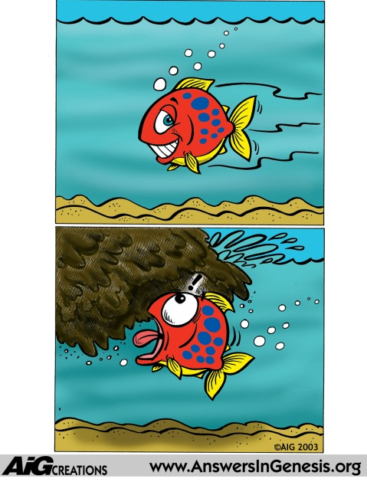
And, behold, I, even I, do bring a flood of waters upon the earth, to destroy all flesh, wherein is the breath of life, from under heaven; and every thing that is in the earth shall die. Gen. 6:17
How do Fossils Form?
- Must be quickly and deeply buried
- Cannot have time to decay
- Must be buried in rich sediment with cementing chemicals
- Must have right amounts of water

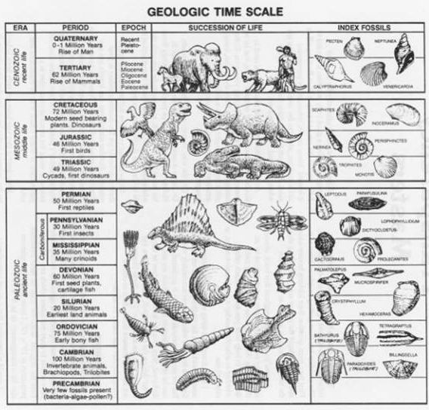
Evolutionary Predictions
- Index Fossils

- Simple to Complex

- Transitional Forms

- Order and Consistency of Layers

- Layers Form Fossil Boundaries

Predictions of the Flood Model
- Layers inconsistent worldwide
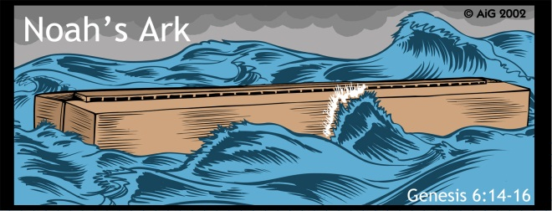
- Fossil show complexity from the beginning
- Fossils match life forms today (Stasis)
- Fossils show abundance of extinct creatures
- Fossils forms are jumbled together
- Fossils extend through multiple layers
- Marine fossils found on the highest mountaintop

